CFLEX 2.0 Environment details

# | Environment | Type
1 | Test7 | Dev Environment for EDMG
2 | Test29 | Dev Environment for Server/Client/Gui
3 | Test30 | Integration Environment

environments for Iterative development
Cognizant proposes two development and one integration testing environments during iterative development phase.
- Development environment for Server, Client & GUI
- Development environment for CDB, DWH, Billing & Market Replay
- Integration Testing environment for New Functional Test Plan and Integration Testing

Development environment for server, client & gui
This development environment will be used for server, client & GUI modules. Cognizant proposes two BC configuration for CFLEX_MAIN session.
Ready Environment (Functionally running) would expected in between: 1st Mar 2011 to 4th Mar 2011
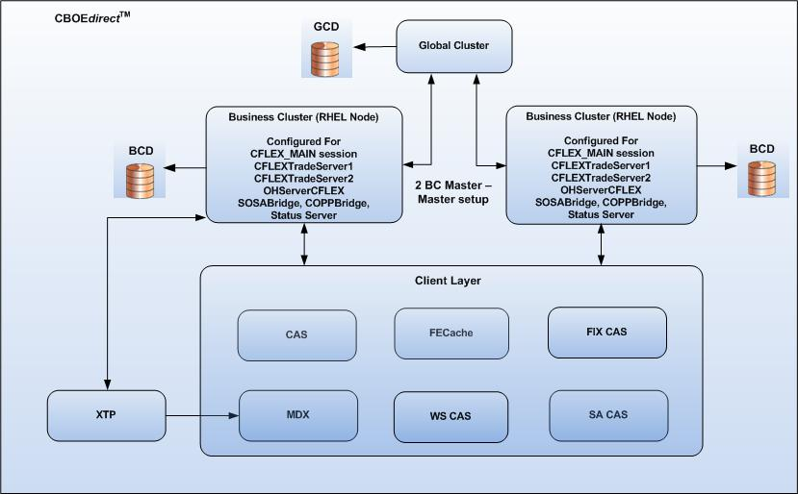

development environment for cdb, dwh, billing & market replay
This development environment will be used for CUT effort of CDB, DWH, Billing & Market Replay.
Ready Environment (Functionally running) would expected in between: 1st Mar 2011 to 4th Mar 2011

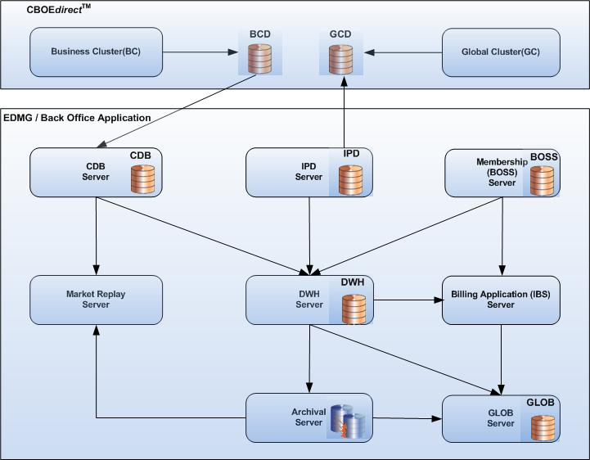

integration testing environment
The integration testing environment will be used for testing unit tested code. The testing will comprise:
- CFLEX 2.0 New Functional Test Plans
- Integration Testing across modules
The CBOE developed modules (XTP, CTMR, IPD & Survelliance) may also hook into this environment for integration testing.

Ready Environment (Functionally running) would expected on or before: 18th Mar 2011

